**Mountain Top Marriages**

**“The Upward Trail”**

**Newsletter**

August , 2019

**Time flies by when you are busy and having FUN!**

We have not sent a newsletter out since last March and so much ministry has happened since then!



**April 6** -Sat all day seminar from 9am -3pm at the Penrose House by the Broadmoor Hotel in Colorado Springs, CO.

**April 9** – Taught a class on marriage at Charis Bible College in Woodland Park, CO

**April 12- April 30** – **Overseas ministry in the UK at several different locations and venues.**

**April 13** - All day seminar at a church in Cambridge.

**April 27-28** – Weekend meetings in Stoke-On-Trent.

We were hosted by Barrie and Carol Dupree.

**May 27-31** – Annual Rocky Retreat in Estes Park - Another week of the couples having amazing encounters with Jesus and lots of healing and deliverance.

The day after the Rocky retreat we got in our car and headed for Florida!

**The summer was full of travel!**

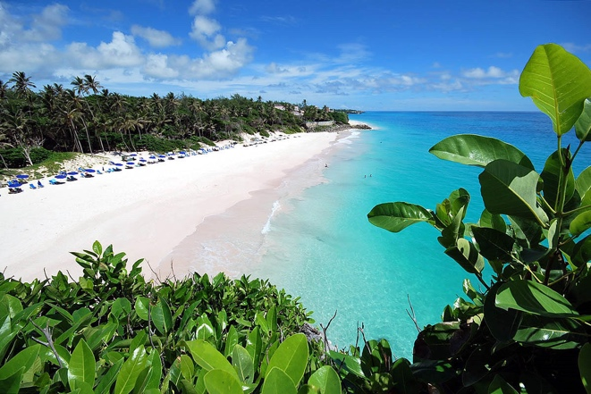

**MONTH OF JUNE** – Personal time spent at a family reunion with kids and grandkids on the coast of Florida. Then drove up the east coast to Maine visiting ministry friends, extended family, and reconnecting. From Maine we came back to Colorado through Niagara Falls, the Black Hills, and Custer State Park.

eas

**July 4- 9** – We entertained Zsolt & Antje Katona from Hungary and their son and his girlfriend that were in the states for Charis Bible College meetings. They stayed in our home while we were traveling in June. They have hosted our marriage retreats in Hungary many times and invited us back in April of 2020. We saw the July 4th fireworks and took them to Rocky Mountain National Park.

**July 23- Aug. 7th - Alaska Trip!**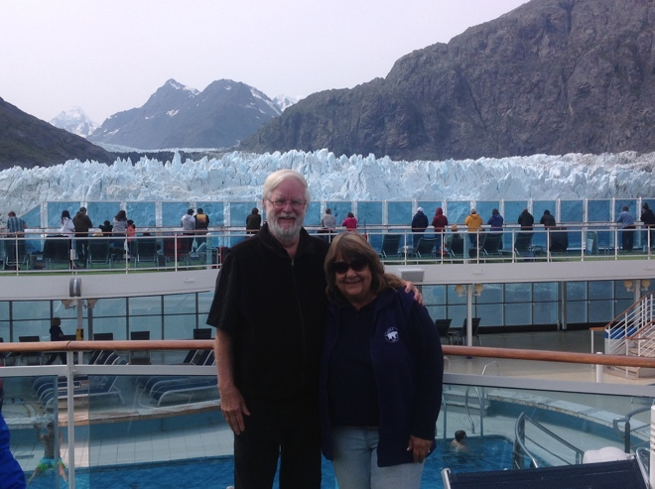

We and Russ & June Gordon and their son Matthew (who are a huge part of our ministry) all flew to Anchorage for 7 days of seeing Alaska by land! We visited Seward, Fairbanks, Valdez and all places in between. Then we took the Princess cruise ship down the inside passage which ended in Vancouver! What an amazing time of viewing glaciers and every form of Alaska’s wildlife!

Gordons are on our ministry board, help us teach, cook and serve food, and help find couples to attend our events! The trip was a HUGE blessing with God surprises every day!

**August 26th** begins the Fall Charis Christian Center **Home Group meetings** held at our home. We will meet the 2nd and 4th Monday night of each month until Nov. 11th. You can sign up at Charis Christian Center Church or on their web site or contact us direct at; [thetravers@mountaintopmarriages.org](mailto:thetravers@mountaintopmarriages.org)

---------------------------------------------------

**IMPORTANT REMINDER……….**

**AUG. 31 – SEPTEMBER 2ND IS THE ANNUAL BRANSON, MO., LABOR DAY WEEKEND RETREAT**

**WE STILL HAVE ROOM FOR MORE COUPLES AT THE BRANSON LABOR DAY RETREAT. WE HAVE CHANGED THE VENUE TO OFFER THE WEEKEND AT LESS COST.**

**IT IS NOW ONLY $150.00/COUPLE.**

**YOU FIND YOUR OWN HOUSING IN BRANSON AND COME TO OUR CONDO UNIT AT STONEBRIGE CONDOMINIUMS ACROSS FROM SILVER DOLLAR CITY.**

**IT IS SAT. AUG. 31 AND SUN. SEPT. 1 FROM 9AM-5PM. EACH NIGHT IS FREE FOR DATE NIGHTS. THEN WE MEET MONDAY MORNING FROM 9AM TILL NOON ON LABOR DAY.**

**PLEASE CALL AND REGISTER ASAP! BECAUSE WE JUST RETURNED FROM ALASKA, REGISTRATION IS OPEN UNTIL AUGUST 28TH. WE CAN ALSO GIVE A $50.00 SCHOLARSHIP TO ANYONE NEEDING FINANCIAL ASSISTANCE.**

**Call our cell @ 913-780-3423 or email us at: thetravers@mountaintopmarriages.org**

------------------------------------------------------

**Sept. 7** – An all day Saturday seminar at Emmanuel Family Church in Shawnee, KS.

**Sept. 14** – Sat. 9am-3pm seminar at Penrose House by the Broadmoor in Colorado Springs, CO.

**October 18-19** – El Tesoro Retreat Lodge seminar overnight in Woodland Park, CO.

**Nov. 17-24** – Cross Points Missions conference in Shawnee, KS.

Keep Climbing,

Roger & Laureen Traver

Mountain Top Marriages